Completing the SF-424A
Budget Information for Non-Construction Programs

Department of the Interior – U.S. Fish and Wildlife Service

Version 1.0
Updated: May 2019

Note: This is an instructional training aid created by the Wildlife and Sport Fish Restoration Program – Division of Financial Assistance Support and Oversight, Training Branch.

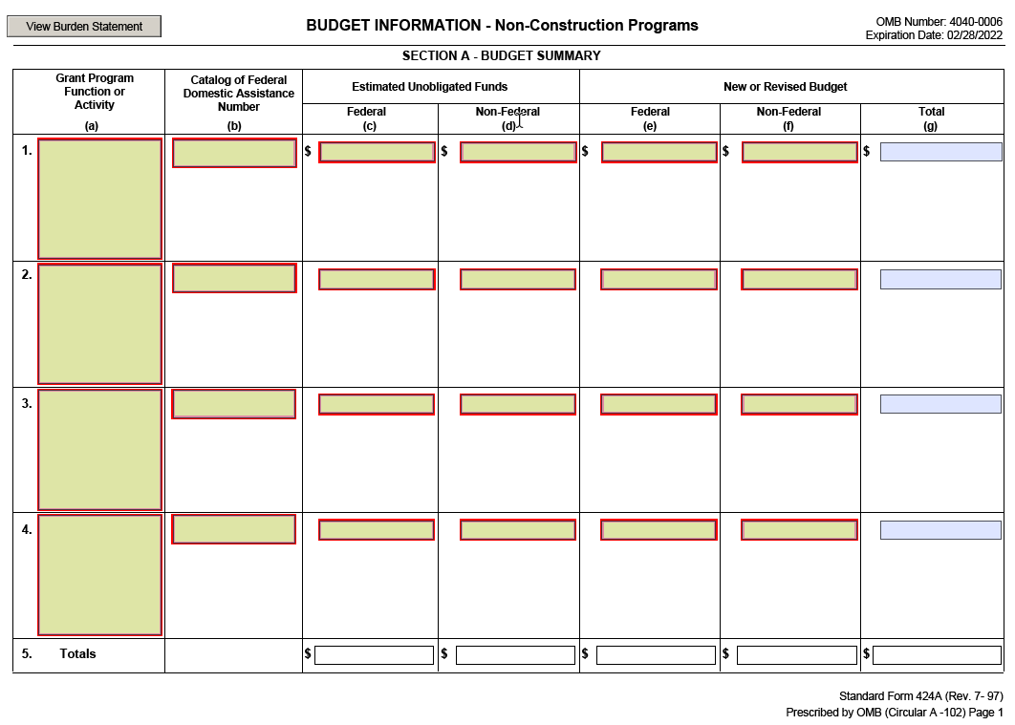
Section A provides a high-level budget summary of your application.

1(a-b) | Grant Program Function or Activity;  Catalog of Federal Domestic Assistance Number | Enter the name of the Service funding program and the corresponding Catalog of Federal Domestic Assistance (CFDA) from which you are applying for funding. The CFDA number will be five digits (##.###) with a period separating the second and third numbers, respectively. For example Sport Fish Restoration (15.605) or National Wildlife Refuge Fund (15.656). The Service funding program name and its corresponding CFDA number can be found in the Service program’s Notice of Funding Opportunity on grants.gov.
1(c-g) | Estimated Unobligated Funds (Federal);  Estimated Unobligated Funds (Non-Federal);  New or Revised Budget (Federal);  New or Revised Budget (Non-Federal);  New or Revised Budget (Total) | If your application requests the Service to fully fund the proposed project at the start of the award…  Enter $0 in Boxes 1c and 1d, respectively. In Box 1e, enter the total amount of Federal funds that you are requesting from the Federal program for this application. In Box 1f, enter the amount of any non-Federal funds either committed as part of your voluntary committed cost sharing or match, or as part of the Federal program’s mandatory cost sharing or matching requirement. Cost sharing or matching funds includes recipient cash and any allowable third party in-kind contributions. If there will be no non-Federal funds, simply enter $0 in Box 1f. Box 1g is the sum total of the dollar amounts listed in Boxes 1c-1f and constitutes the total Federal award amount being requested from the Federal program in your application. If completing the SF-424A electronically, the form automatically calculates this field once you enter the amounts in Boxes 1c-1f.  If your application requests the Service to award future funds incrementally…  Enter in Box 1e, the total amount of Federal funds that you are requesting be made available to the applicant during the current funding period. In Box 1f, enter the amount of any non-Federal funds during the current funding period either committed as part of your voluntary committed cost sharing or match, or as part of the Federal programs mandatory cost sharing or matching requirements. In Boxes 1c and 1d, enter the amount of Federal and non-Federal funds that you are requesting to be added to the award in future fiscal years or funding periods. For example, you are applying for a $30,000 award (with no cost sharing or matching requirement) with a three-year period of performance. You request that $10,000 be authorized by the Federal program during each year of the award (subject to the future availability of Federal funds). Enter $20,000 in Box 1c, $0 in Box 1d, $10,000 in Box 1e, and $0 in Box 1f. Box 1g shows the sum total requested Federal award amount of $30,000 if you have completed the form electronically.
2-4(a-g) |  | Rows 2-4 are used to identify any additional Federal programs that are or may be providing funding to assist with the proposed project. In each row, identify the Federal grant program, its CFDA number, and the amount of Federal and non-Federal funds contributed to the project under that Federal program, similar to Row 1. If no additional Federal programs will be contributing funding, then simply leave Rows 2-4 blank. If more than three additional Federal programs are contributing funding, provide this information in a separate attachment.
5 | Totals | Enter the sum total of the amounts in Columns (c) - (g). If completing the SF-424A electronically, the form automatically calculates these fields once you enter all the amounts in Columns (c) - (g). Box 5g is the total award amount requested from all Federal funding programs for the proposed project.

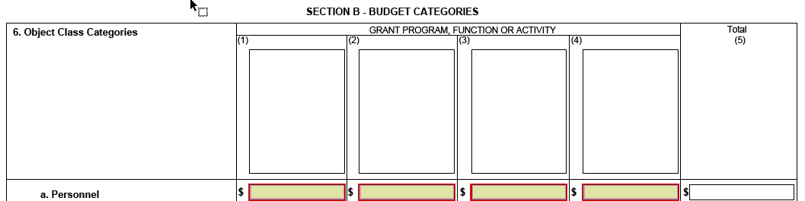

Section B Budget Categories, provides the estimated dollar amounts for expenditures, by budget or object class, for your application. The dollar amounts entered under each Federal program in Columns 1 - 4 should include both Federal funds and any non-Federal funds that are part of your voluntary committed cost share or mandatory cost sharing or matching requirements, if applicable.
Column 1 | Grant Program, Function, or Activity | Enter the name of the Federal program that you are presently applying for funding. This should be the same Federal program name that you entered in Section A - Box 1a. If you complete the SF-424A electronically, the form automatically populates these fields after you enter the names of the Federal programs in Section A – Boxes 1a.
Columns 2-4 | Grant Program, Function, or Activity | Enter the name or names of any additional Federal programs that may be providing funding to assist with this Federal award. These Federal program names should be the same as those entered in Section A – Boxes 2a, 3a, and 4a. If no additional Federal programs will be providing funding, then simply leave Columns 2-4 blank. If you complete the SF-424A electronically, the form automatically populates these fields after you enter the names of the Federal programs in Section A – Boxes 2a, 3a, and 4a. If more than three additional Federal programs may be providing funding, simply provide the additional rows of budget category information in a separate attachment.
Column 5 | Total | Automatically calculates when completing the form electronically and represents the summation of each budget or object class category amount in Rows (a) through (k) from all Federal programs that are contributing funding to the proposed project.

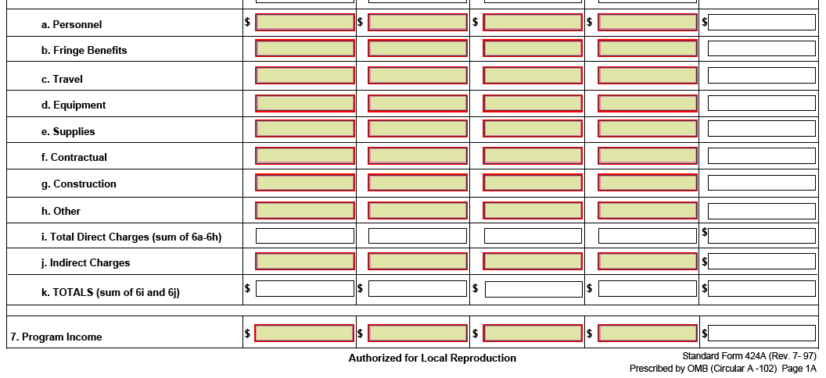

(a) | Personnel | Enter the amount of funds that are estimated for personnel costs for each Federal program. Personnel costs generally include the salaries or wages of employees expected to perform the activities of the proposed project during the award period of performance. Depending on the project type, personnel costs are often the largest budget category of cost of a Federal award. Please review 2 CFR 200.430 “Compensation - personal services” when determining what personnel costs may be allowable to charge to a Federal award, as well as the standards for adequate documentation. If no personnel costs are being requested from the Federal program, simply enter $0.
(b) | Fringe Benefits | Enter the amount of funds that are estimated for fringe benefits for each Federal program. Fringe benefits are generally those allowances and services provided by an employer to their employees as part of their compensation package, above and beyond the employee’s regular salaries and wages. Typical examples of fringe benefits often include, but are not necessarily limited to, the costs of leave (such as sick, vacation, military, and family-related), health and life insurance, pensions or other retirement type benefits, social security, unemployment benefits, severance payments, and tuition waivers or reductions. Please review 2 CFR 200.431 “Compensation - fringe benefits” to better understand the circumstances that may affect the allowability of fringe benefits to be charged to a Federal award. If no fringe benefit costs are being requested from the Federal program, simply enter $0.
(c) | Travel | Enter the amount of funds that are estimated for travel for each Federal program. Travel costs include expenses for transportation, lodging, subsistence/meals, and other related items incurred by employees who are in travel status on official business of the applicant. Please review 2 CFR 200.474 “Travel costs” to better understand the circumstances that may affect the allowability of travel costs to be charged to a Federal award and the requirements for obtaining prior approval from the Service. If no travel costs are being requested from the Federal program, simply enter $0.
(d) | Equipment | Enter the amount of funds that are estimated for equipment acquisition or depreciation for each Federal program. Under Federal financial assistance, equipment is defined at 2 CFR 200.33 to include tangible personal property (including information technology systems) having a useful life of greater than one year and a per-unit acquisition cost which equals or exceeds the lesser of the capitalization level of the non-Federal entity, or $5,000. General purpose equipment is further defined at 2 CFR 200.48 to include equipment which is not limited to research, medical, scientific, or other technical activities such as motor vehicles, office equipment, printing equipment, and HVAC equipment. Special purpose equipment is defined at 2 CFR 200.89 to include equipment that is used only for research, medical, scientific, or other technical activities. Examples of special purpose equipment includes x-ray machines, microscopes, surgical instruments, fish stocking trucks, and electrofishing boats. Please review 2 CFR 200.439 “Equipment and other capital expenditures” to better understand the circumstances that may affect the allowability of equipment costs to be charged to a Federal award and the requirements for obtaining prior approval from the Service. Applicants should also review 2 CFR 200.436 concerning charging depreciation costs of previously acquired equipment to a Federal award. If no equipment costs are being requested from the Federal program, simply enter $0.
(e) | Supplies | Enter the amount of funds that are estimated for supplies for each Federal program. Supplies are defined at 2 CFR 200.94 to include all tangible personal property other than those described as equipment at 2 CFR 200.33. Examples of supplies include paper, pens and pencils, computing devices (if the acquisition cost is less than the definition of equipment), and office furniture. Please review 2 CFR 200.314 to better understand the requirements for the use and disposition of supplies acquired on a Federal award. If no supply costs are being requested from the Federal program, simply enter $0.
(f) | Contractual | Enter the amount of funds that are estimated for contractual costs for each Federal program. Contracts are defined at 2 CFR 200.22 to mean those legal instruments by which the applicant purchases and obtains property or services needed to carry out a project or program under a Federal award. Contracts do not include those legal instruments, even if the applicant considers it a contract, when the substance of the transaction meets the definition of a Federal award or subaward at 2 CFR 200.92. If no contractual costs are being requested from the Federal program, simply enter $0.
(g) | Construction | Enter the amount of funds that are estimated for construction and other types of capital expenditures for each Federal program. Capital expenditures are defined at 2 CFR 200.13 to include those expenditures to acquire capital assets or those expenditures to make additions, improvements, modifications, replacements, rearrangements, reinstallations, renovations, or alterations to capital assets that materially increase their value or useful life. Capital assets means tangible or intangible assets used in operations having a useful life of more than one year which are capitalized in accordance with Generally Accepted Accounting Principles (GAAP). Examples of capital assets include land, buildings, facilities, equipment, and intellectual property. Please review 2 CFR 200.439 to better understand the circumstances that affect the allowability of these costs to be charged to a Federal award and the requirements for obtaining prior approval from the Service. If no construction or capital expenditure costs are being requested from the Federal program, simply enter $0.
(h) | Other | Enter the amount of funds that are estimated for all other direct costs for each Federal program. Costs included in this category may differ from applicant to applicant. They may include, but are not limited to, subawards, rental costs of buildings and facilities, printing costs, conference costs, employee training, participant support costs, recruitment costs, and relocation costs. Applicants should exercise discretion to ensure that the types of costs included here are not already included in other budget cost categories or in your organization’s Federally-negotiated indirect cost rate. Applicants should review the Cost Principles at 2 CFR 200 Subpart E to better understand the circumstances that may affect the allowability of costs included in the “Other” budget category to be charged to a Federal award and any requirements for obtaining prior approval from the Service. If no additional or other costs are being requested from the Federal program, simply enter $0.
(i) | Total Direct Charges | Enter the sum total of the amounts entered in Boxes 6(a) through 6(h), for each Federal program. If completing the SF-424A electronically, the form automatically calculates these fields once you enter the amounts in Boxes 6(a) through 6(h) for each Federal program.
(j) | Indirect Charges | Enter the amount of funds that are estimated for the allocable amount of indirect costs for each Federal program. Indirect costs are those costs that are incurred for a common or joint purpose benefitting more than one cost objective, and not readily assignable to the cost objectives specifically benefitted, without an effort disproportionate to the results achieved. Due to the diverse characteristics and organizational practices of different types of applicants, the types of costs that may be classified as indirect costs often vary from applicant to applicant. Applicants without an approved Negotiated Indirect Cost Rate Agreement are prohibited from charging indirect costs to a Federal award. If you fail to establish an approved indirect rate during the award period of performance, then all costs otherwise allocable as indirect costs are unallowable to the Federal award. If no indirect costs are being requested from the Federal program, simply enter $0.  If you are an individual applying for Federal financial assistance separate from a business or non-profit organization that you operate, then you are not eligible to charge indirect costs and should not include indirect costs in your budget. Simply enter $0 in Box 6(j).
(k) | Totals | Enter the sum total of amounts entered in Boxes 6(i) and 6(j) for each column and equals the total budget amount being requested from each Federal program. These amounts should equal the amounts listed in Boxes 1(g) thru 4(g) of Section A for each Federal program. If you are completing the SF-424A electronically, the form completes this calculation for you automatically once you enter the amounts in Boxes 6(i) and 6(j).
Row 7 | Program Income | Enter the amount of Program Income that you anticipate will be earned during the award period of performance under Column 1. Enter anticipated program income amounts to be earned during the period of performance of any other contributing Federal program, as applicable, under Columns 2 through 4. Program income is defined at 2 CFR 200.80 to include gross income earned by the non-Federal entity that is directly generated by a supported activity or earned as a result of the Federal award during the period of performance. Leave Row 7 blank if program income is not anticipated.

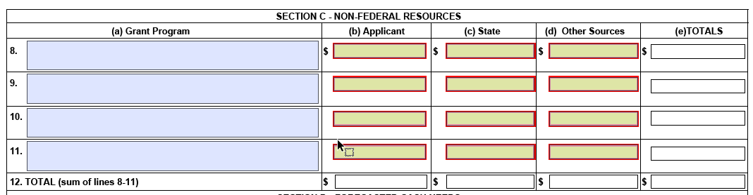

Section C: Non-Federal Resources is found on page 3 of the SF-424A and is used to identify the source or sources of any non-Federal funding that is being contributed as part of your voluntary committed cost sharing or match, or as part of a Federal programs mandatory cost sharing or matching requirements, if applicable. Cost sharing or matching funds includes recipient and third party cash and any allowable third party in-kind contributions.
(a) | Grant Program | In Box 8a, enter the name of the Federal program that you are presently applying for funding as you did in Box 1(a) of Section A.  Similarly, in Boxes 9a, 10a, and 11a, enter the name or names of any additional Federal programs that may be contributing funding to assist with the objectives of the proposed project, as you did in Box 2-4(a) of Section A. Leave these fields blank if no additional Federal programs will be contributing funding.  If you complete the SF-424A electronically, the form automatically populates these fields after you enter the names of the Federal programs in Section A – Boxes 1a, 2a, 3a, and 4a. If more than three additional Federal programs may be contributing funding, simply provide the additional rows of non-Federal funding information in a separate attachment.
(b) | Applicant | Enter the amount of any non-Federal funds contributed by you, the applicant, as cost sharing or matching. If you are not contributing any match, then simply enter $0.
(c) | State | Enter the amount of any non-Federal funds, to include cash or third-party in-kind contributions, contributed by one or more State agencies as match, if applicable. Applicants should verify with their state agency partners that amounts contributed to the proposed project as match are not from Federal sources. If no State agencies will be contributing non-Federal funds as match, then simply enter $0.
(d) | Other Sources | Enter the amount of any non-Federal funds, to include cash or third-party in-kind contributions, contributed by all other sources, if applicable. If there will be no other sources of non-Federal funds contributed as match, then simply enter $0.
(e) | TOTALS | Enter the summation, by row, of the amounts entered in Columns b, c, and d. This represents the total amount of all non-Federal funding contributed under each Federal program and is automatically calculated when completing the form electronically.
Row 12 | TOTAL (sum of lines 8-11) | Enter the summation of the non-Federal funding amounts provided by the applicant, State, and other sources. The form automatically populates these fields after you enter the amounts in Rows 8-11, if applicable.

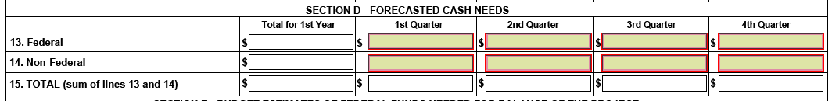

Section D, provides an estimate of the amount of Federal funds and any non-Federal funds, if applicable, that are needed to satisfy your cash needs during the first year of the Federal award. The amount of Federal and non-Federal funds needed should include the total amount of funds provided by all Federal programs and non-Federal sources, as applicable. The estimated amount of forecasted cash needs is useful to Federal awarding agencies in monitoring payments disbursed to the recipient of an award as compared to performance expectations or milestones met. Applicants are reminded that 2 CFR 200.305 requires that payments must minimize the time elapsing between the transfer of funds from the U.S. Treasury or the pass-through entity and the disbursement by the non-Federal entity to only those amounts needed to meet their immediate cash requirements. For State recipients, payment procedures are governed by their Treasury-State Cash Management Improvement Act agreements (for those Federal programs designated as major programs) and the default procedures codified at 31 CFR 205 (for those Federal programs not designated as major programs).
Row 13 | Forecasted Cash Needs: Federal | Enter the amount of your Federal funds cash needs, from all Federal sources, during the first, second, third, and fourth quarters of the first year of the Federal award. If no Federal funds are forecasted to be needed in a specific quarter, then enter $0 for that quarter. The “Total for 1st Year” field will automatically calculate the sum total of the quarterly amounts once they’re entered.
Row 14 | Forecasted Cash Needs: Non-Federal | Enter the amount of your non-Federal funds cash needs, from all non-Federal sources, during the first, second, third, and fourth quarters of the first year of the Federal award. If no non-Federal funds are required or forecasted to be needed in a specific quarter, then enter $0 for that quarter. The “Total for 1st Year” field will automatically calculate the sum total of the quarterly amounts once they’re entered.
Row 15 | Forecasted Cash Needs: TOTAL (sum of lines 13 and 14) | Enter the summation of the forecasted Federal and non-Federal cash needs for the first, second, third, and fourth quarters, and the total for the first year of the Federal award. The form automatically populates these fields after you enter the amounts in Rows 13 and 14.

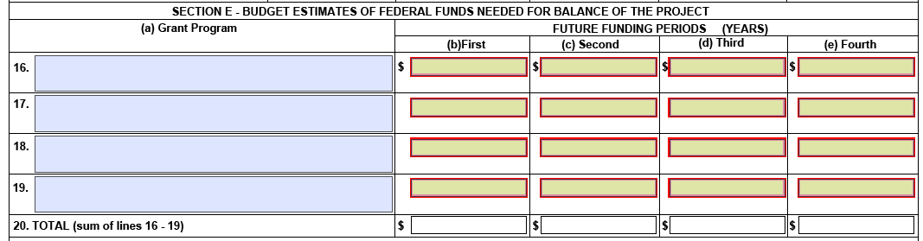

Section E provides information about the amount of future estimated Federal funds, from each Federal program, that are needed for the balance of the project. The form provides the opportunity to enter up to four future funding years. If more than four additional years of future Federal funding is required for your project, simply provide the additional information in a separate attachment.
(a) | Grant Program | In Box 16a, enter the name of the Federal program that you are presently applying for funding as you did in Box 1(a) of Section A. Similarly, in Boxes 17a, 18a, and 19a, enter the name or names of any additional Federal programs that may be contributing funding to assist with the objectives of the Federal award, as you did in Boxes 2-4(a) of Section A. Leave these fields blank if no additional Federal programs will be providing funding. If you complete the SF-424A electronically, the form automatically populates these fields after you enter the names of the Federal programs in Section A – Boxes 1a, 2a, 3a, and 4a. If more than four Federal programs may be providing future Federal funding, simply provide the additional rows of future Federal funding in a separate attachment.
(b-e) | Future Funding Periods: First, Second, Third, and Fourth | In Box 16b, enter the amount of estimated future Federal funds, from the Federal program listed in Box 16a, that are needed during the first future funding period. Do not include any estimated future non-Federal funding needed as either voluntary committed cost share or to meet mandatory cost sharing or matching requirements. In Boxes 16c, 16d, and 16e enter the amount of estimated future Federal funding that is needed during the second, third, and fourth future funding periods. For any additional Federal programs listed in Rows 17a-19a, complete the boxes provided in Columns b-e by listing the estimated future Federal funding amounts needed to complete the balance of the project in future funding periods. If no future Federal funding is needed for the project, simple enter $0.
Row 20 | Future Funding Periods: TOTAL (sum of lines 16-19) | Enter the sum total of the estimated Federal funding amounts listed in Columns b-e as needed for the balance of the project in future funding periods. The form automatically populates these fields after information is entered into columns (b) through (e) of rows 16-19.
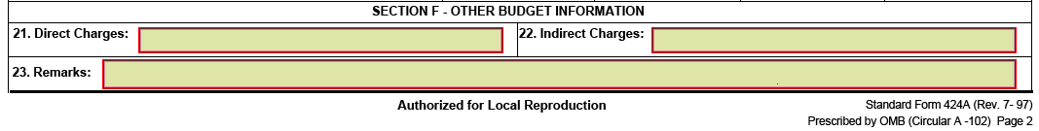
The last part of the SF-424A is Section F and provides other budgetary details, such as information on direct and indirect costs, as well as any additional information that may be required by the Service as stated in the Federal funding program’s statute, regulation, or Notice of Funding Opportunity.
21 | Direct Charges | Enter information to describe and justify the amounts that comprise each of the individual budget or object class categories you identified in Section B of the SF-424A. A separate attachment may be necessary. You should provide details as to how the amounts listed for each budget or object class category were determined. For example, if personnel costs are included, you may include baseline salary figures and the estimates for time. You should also describe any item of cost that requires prior approval under the Federal cost principles. Many Service programs require a Budget Narrative to be included as part of a complete application package. If you have provided this information and detail in a separate Budget Narrative, then simply enter, “See attached Budget Narrative”.
22 | Indirect Charges | If you are eligible and request to charge indirect costs to the Federal award, enter the approved indirect rate, the type of rate, and distribution base to which the rate will be charged. There are several types of indirect rates including: (1) Provisional Rate; (2) Final Rate; (3) Predetermined Rate; (4) Fixed Rate with Carry-Forward; (5) Special Rate; and (6) 10% de minimis. If you are unsure as to what type of indirect rate you are approved to apply to the award, refer to your Negotiated Indirect Cost Rate Agreement. Applicants should review the Service programs Notice of Funding Opportunity for any additional indirect cost information that may be required to be included in your application or on the SF-424A.
23 | Remarks | Enter any additional remarks or information concerning your budget. If more information is provided then will fit in the box, then simply provide the information in a separate attachment and enter “See Remarks attachment”. This box is often useful for applicants to identify the types of costs, such as subawards, participant support costs, conferences, and training, that were included in the “Other” object class category in Section B of the SF-424A. Applicants should review the Service programs Notice of Funding Opportunity for any specific information that should be include in Box 23. Similar to Box 21, many Federal programs require a Budget Narrative to be included as part of a complete application package. If you have already provided information in a separate Budget Narrative, then simply enter, “See attached Budget Narrative”.

