Angler Education
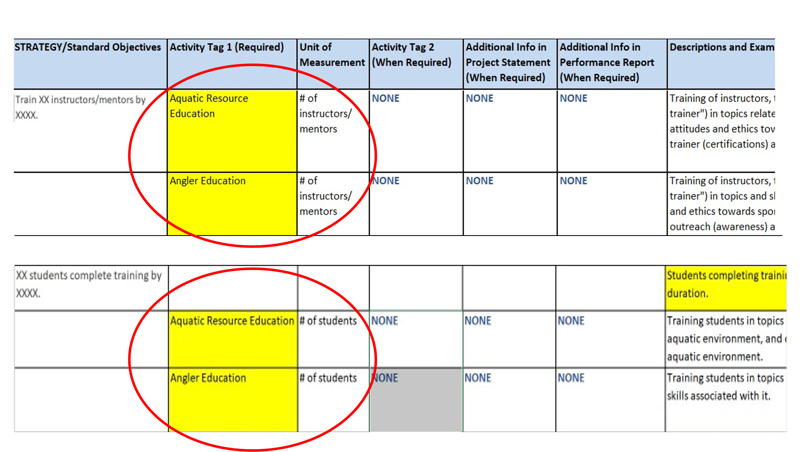
This change effectively adds Angler Education as a measurable activity by moving it from TAG 2 to TAG 1 for both # of Instructors and # of Students.

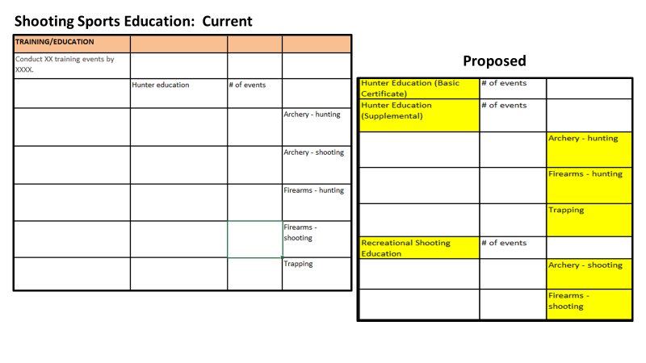This change effectively splits Hunter Education into Hunter Education (Basic Certificate) and Hunter Education (Supplemental); and adds Recreational Shooting Education as a measurable activity and adds Archery Shooting and Firearms Shooting as TAG 2’s (reportable, but not measurable).

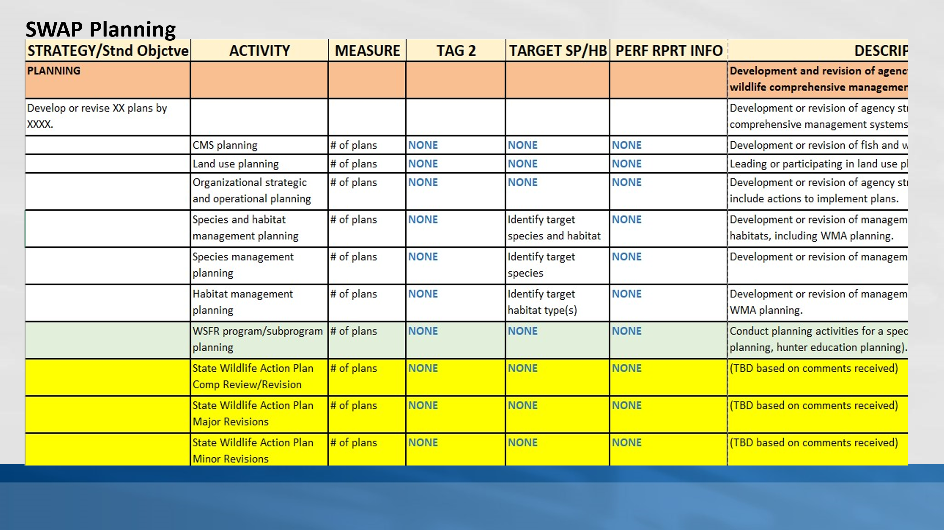

This change effectively adds three measurable SWAP Planning Activities to the Matrix: Comprehensive Review and Revisions; Major Revisions; and Minor Revisions.

